SIMATS ENGINEERING

ASSESSMENT TOOL 3

COURSE NAME: COMPUTER NETWORKS COURSE CODE: CSA07

COURSE OUTCOME COVERED

CO4:
Design network topologies star, mesh, bus, and hybrid using networking devices, transmission media, and cabling standards
(BL2,BL6)

Assessment Tool Weightage: 30%

QUESTIONS: 5 Total Marks:25
Annexure A

Comparative Analysis
- Star topology is generally more expensive than bus topology because it requires a central device such as a switch or hub and more cabling to connect each node individually. In contrast, bus topology uses a single backbone cable, making it low-cost and easier to install. However, in terms of reliability, star topology is superior because failure of one node does not affect others, whereas a failure in the main bus cable can bring down the entire network. Performance is also better in star topology since data transmission is managed through a central device, reducing collisions, while bus topology suffers from performance degradation as more devices are added due to increased data traffic on the shared medium.
- Mesh topology offers very high fault tolerance because every node is connected to multiple other nodes, providing multiple paths for data transmission. If one link fails, data can still be routed through alternate paths without disrupting communication. In contrast, star topology has moderate fault tolerance; while failure of individual nodes does not affect the network, failure of the central hub or switch can cause the entire network to stop functioning. Therefore, mesh topology is more robust and reliable in critical environments compared to star topology.
- Bus topology is simple and easy to install because it uses a single backbone cable with minimal connections, making it suitable for small networks. On the other hand, mesh topology is highly complex to install as each node must be connected to every other node, requiring a large number of cables and ports. This complexity increases significantly as the number of devices grows, making mesh topology time-consuming and costly to implement compared to the straightforward setup of bus topology.
- Hybrid topology is highly scalable because it combines two or more different topologies (such as star, mesh, or bus), allowing the network to expand flexibly according to organizational needs. New segments can be added without affecting the existing network structure. In comparison, star topology is also scalable but to a limited extent, as it depends on the capacity of the central device (switch or hub). Once the central device reaches its port limit, expansion requires additional hardware. Thus, hybrid topology provides greater scalability than star topology.
- In terms of maintenance, star topology is relatively easy to manage because issues can be quickly identified and isolated to a specific node or cable. Mesh topology, while highly reliable, is difficult to maintain due to its complex structure and large number of connections, making troubleshooting time-consuming. Bus topology is harder to maintain than star because faults in the backbone cable can disrupt the entire network and are difficult to locate. Hybrid topology has moderate maintenance complexity; while it benefits from flexibility, managing multiple combined topologies requires careful monitoring and skilled administration.

RUBRICS FOR CALCULATION

Criteria | Weightage | Exemplary (4) | Proficient (3) | Developing (2) | Beginning (1)
Understanding of Concepts | 15% | Demonstrates complete and in-depth  understanding of all concepts being compared | Good understanding with minor  gaps | Basic understanding; some concepts unclear | Poor understanding of concepts
Comparison Depth | 20% | Provides detailed, insightful, and meaningful  comparisons  across multiple aspects | Adequate comparison with relevant points | Limited comparison; lacks depth | Minimal or incorrect comparison
Criteria Selection | 10% | Selects highly relevant and  appropriate comparison parameters | Mostly relevant criteria | Some irrelevant or missing  criteria | Poor or no criteria selection
Analytical Skills | 15% | Strong analysis with logical reasoning and clear justification | Good analysis with some justification | Basic analysis with weak reasoning | No clear analysis
Organization & Structure | 10% | Well-organized, clear, and logically structured | Generally organized | Somewhat disorganized | Poorly structured
Use of  Examples / Evidence | 10% | Uses strong, relevant  examples or data to support comparison | Uses some examples | Limited examples | No supporting examples
Clarity of Presentation | 10% | Very clear, concise, and easy to understand | Mostly clear | Somewhat unclear | Difficult to understand
Conclusion & Insights | 10% | Insightful conclusion with strong justification | Clear conclusion | Basic conclusion | No or weak conclusion

1.Star Topology vs Bus Topology – Cost, Reliability and Performance

- Star topology is generally more expensive than bus topology because it requires a central device such as a switch or hub and separate cables to connect every device.

- In bus topology, all devices share a single backbone cable, so less cable and equipment are required. Therefore, bus topology is cheaper and easier to install.

- In terms of reliability, star topology is more reliable because failure of one node or cable affects only that particular device. The remaining devices continue to work normally. However, if the central switch or hub fails, the entire network can be affected. In bus topology, failure of the main backbone cable can stop communication throughout the network.

- Star topology also provides better performance because the switch manages communication between devices and reduces unnecessary data traffic. Bus topology may experience more collisions and slower performance when many devices are connected. Thus, star topology is more suitable for modern networks despite its higher cost.
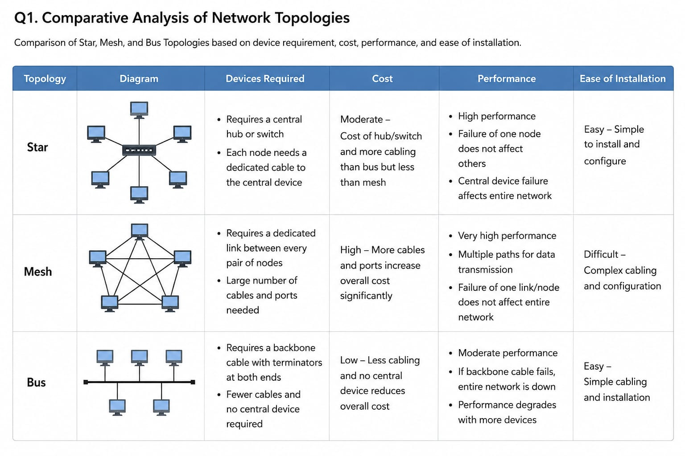
2. Mesh Topology vs Star Topology – Fault Tolerance

- Mesh topology provides very high fault tolerance because each node has multiple connections with other nodes. This creates several alternative paths for data transmission. If one connection fails, data can use another available path, allowing the network to continue functioning.

- Star topology has comparatively moderate fault tolerance. If one connected device or its cable fails, only that device is affected.

- However, the central switch or hub is a critical point. If it fails, communication between the connected devices can be interrupted.

- Mesh topology is therefore more reliable for critical applications where continuous communication is important. However, its high reliability comes with increased cost, cabling, installation complexity and maintenance requirements. Star topology is simpler and more economical for normal organizational networks.
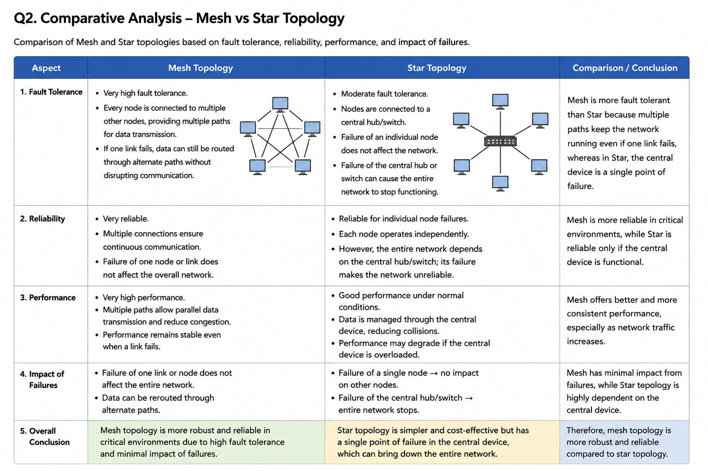

3. Bus Topology vs Mesh Topology – Installation Complexity

- Bus topology is simple and easy to install because all devices are connected to a single backbone cable. It requires fewer cables, connectors and networking devices. This makes it economical and suitable for small networks with a limited number of computers.

- Mesh topology is much more complex because each device needs a connection with several or all other devices. As the number of nodes increases, the number of connections also increases significantly. This results in higher requirements for cables, ports, networking equipment and installation time.

- Although mesh topology provides excellent reliability and multiple communication paths, its installation is time-consuming and expensive.

- Bus topology is therefore easier to implement, while mesh topology is preferred when reliability and fault tolerance are more important than simplicity.
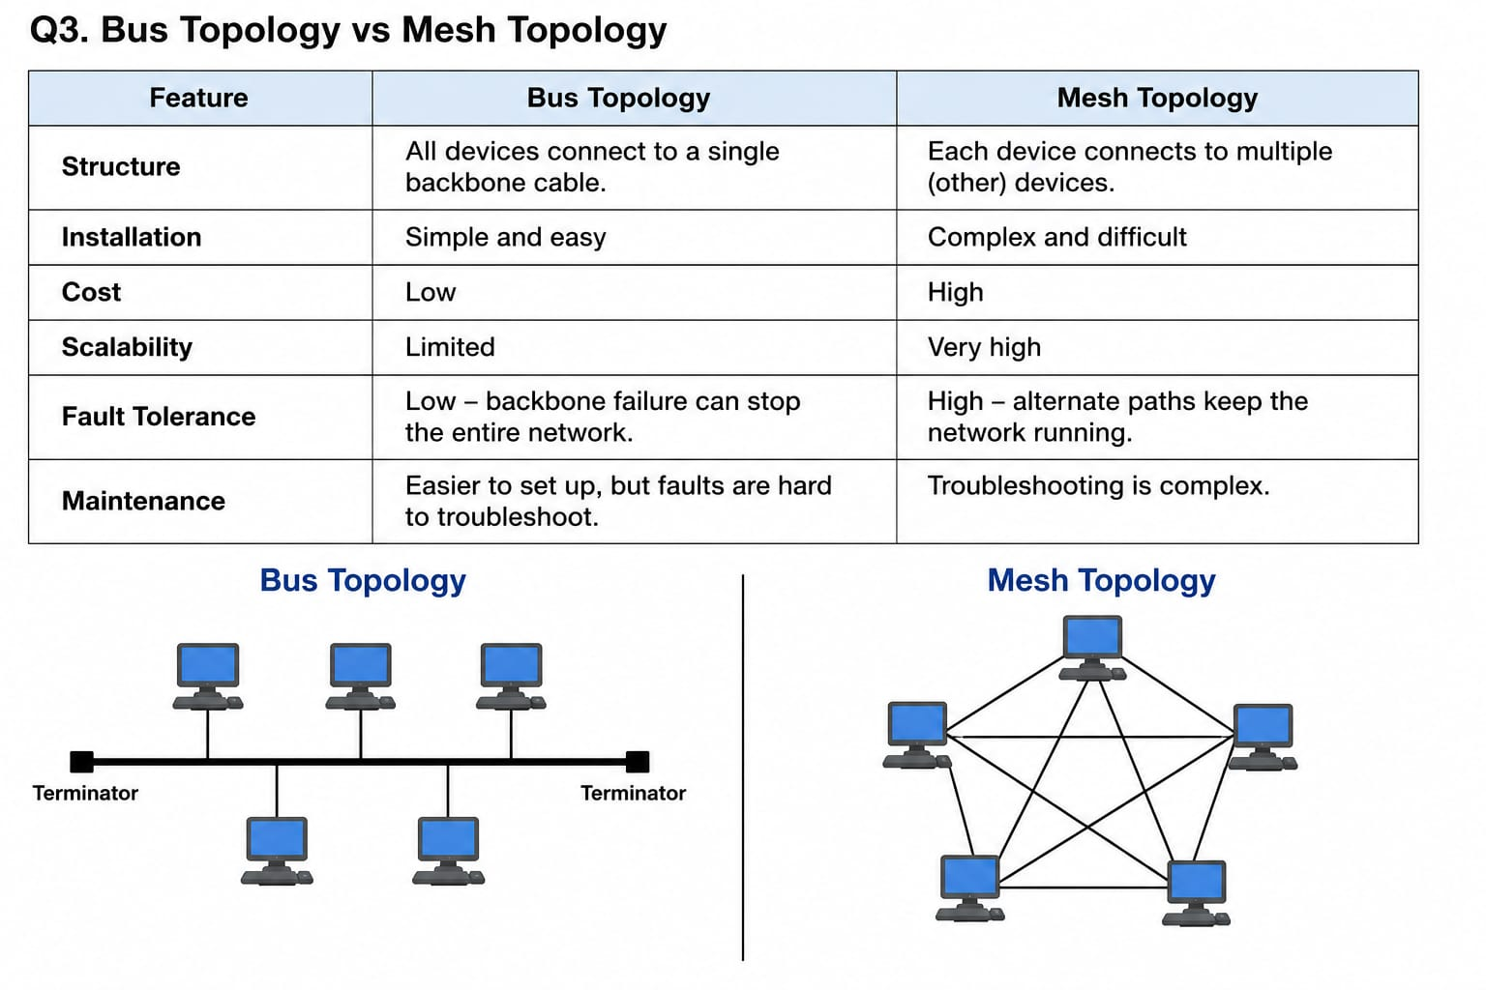

4. Hybrid Topology vs Star Topology – Scalability

- Hybrid topology provides high scalability because it combines two or more different network topologies, such as star, bus or mesh. Organizations can design different sections of a network according to their requirements and connect these sections together.

- New devices or network segments can be added without completely changing the existing network. This makes hybrid topology suitable for large organizations, universities, banks and other growing networks.

- Star topology is also scalable because new devices can be connected to the central switch or hub. However, its expansion is limited by the number of available ports and the capacity of the central device. Additional switches may be required when the number of devices increases.

- Therefore, hybrid topology provides greater flexibility and scalability, while star topology offers simpler and more straightforward expansion.
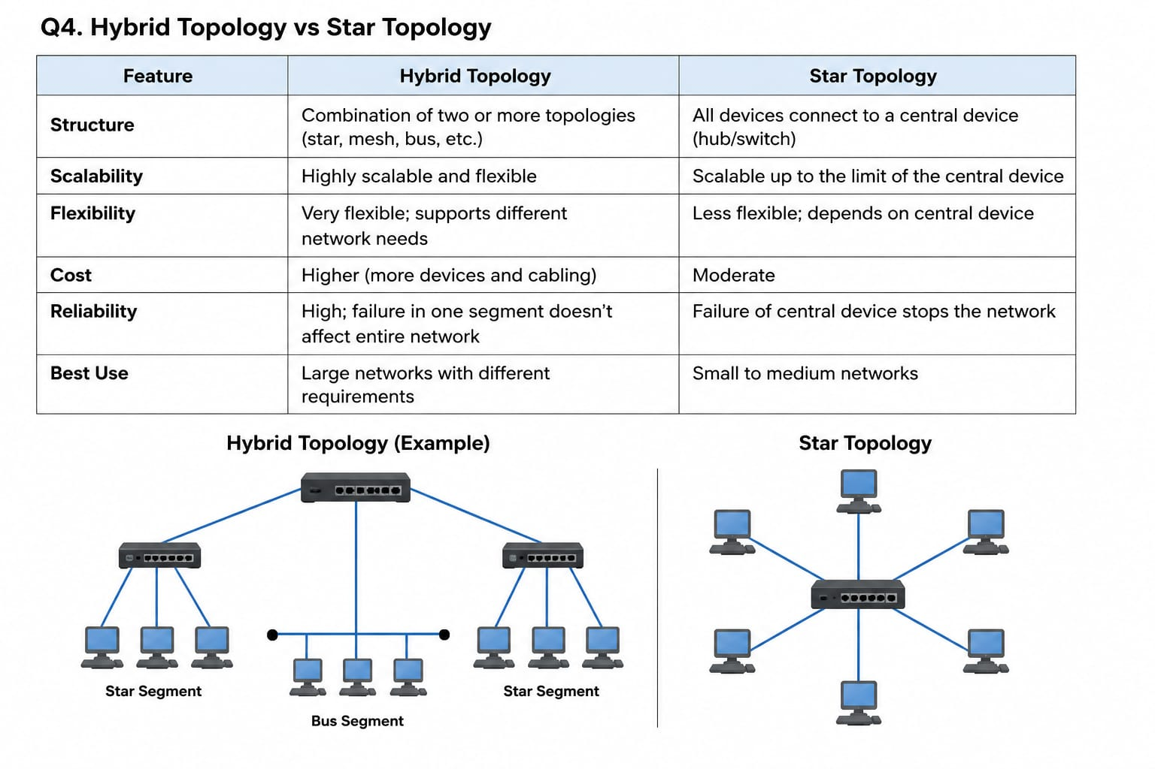

5.Maintenance of Star, Mesh, Bus and Hybrid Topologies

- Star topology is generally easy to maintain because each device has an individual connection to the central switch or hub. If a problem occurs, the faulty device or cable can usually be identified easily without affecting the rest of the network.

- Mesh topology is highly reliable but difficult to maintain because it contains a large number of connections. Identifying and repairing a faulty connection can take more time and requires skilled network administrators.

- Bus topology is relatively difficult to troubleshoot because many devices share the same backbone cable. A problem in the backbone can affect the entire network, and locating the exact fault may be challenging.
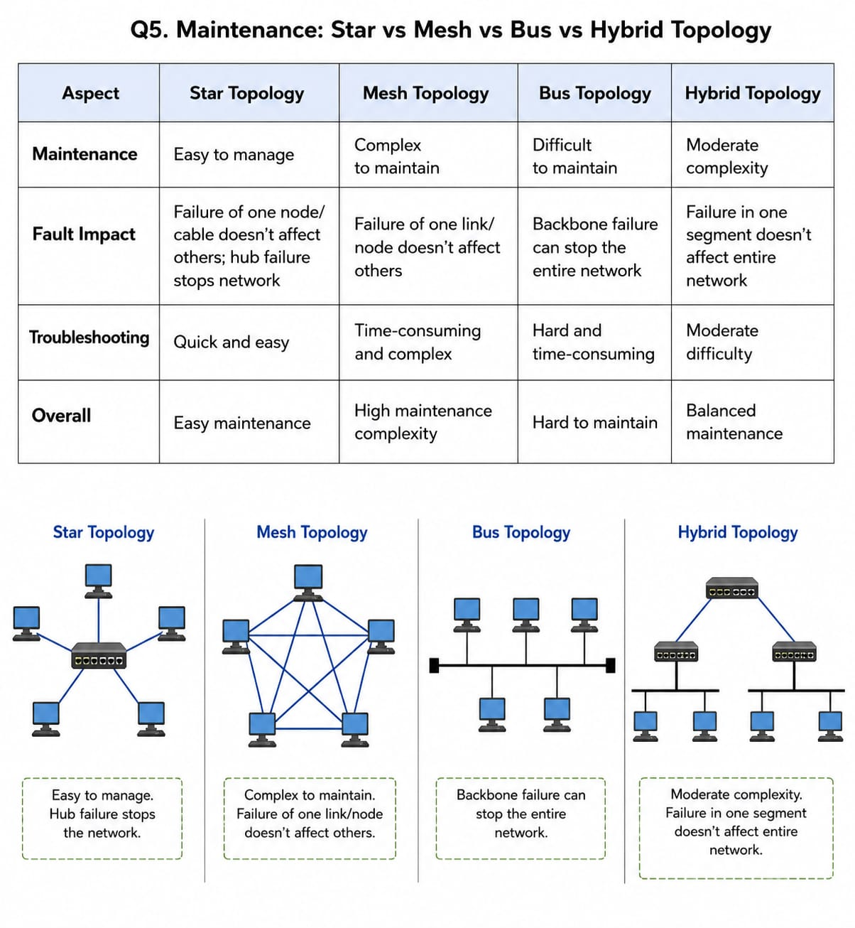
- Hybrid topology has moderate maintenance complexity. Since it combines different topologies, administrators must understand and manage each section separately. However, its flexible structure allows faults to be isolated to a particular network segment.

- Thus, star topology is generally the easiest to maintain, mesh topology is the most complex, bus topology can be difficult to troubleshoot, and hybrid topology requires careful monitoring and skilled administration.

